TEACCH =
Teaching and Education of Autistic and Communication Handicapped Children
Founder =
Eric Shopler (1970s), North Carolina University
Settings =
Home/ Residential/ Specialist & Mainstream Schools
TEACCH

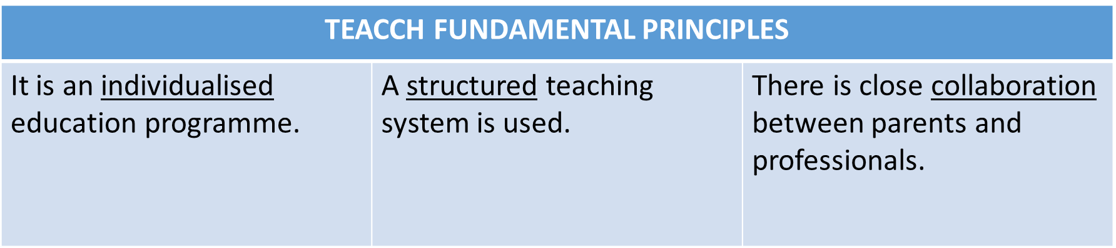

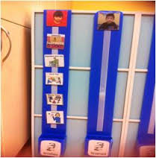



- Physical environment

- The use of visual schedules

- Objects of special interests
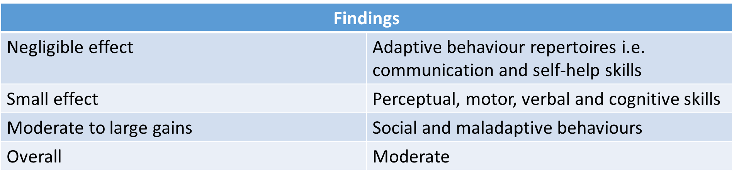
Preliminary Meta-Analysis (Virues-Ortega et al.,2013)

- Variation exists according to the assessment methods used; the target population selected; the duration and intensity of the programme; and which aspects of the intervention are measured.

- Virues-Ortega et al. (2013) believe that such variability, ‘precludes a straightforward appreciation of the treatment effectiveness’ (p. 941).

Concluding thoughts:

- TEACCH was designed to represent a ‘model’ or a ‘template’ to educational professionals and parents.

- It can be adapted to meet the needs of individual children and families, in different cultural and social contexts.

- More research is needed to identify and systemically evaluate individual components of the programme…

- But “what is neat is not always best” (Mesibov and Shea, 2010)

